7. **Income statement:** presents the revenues and expenses and resulting net income or net loss for a specific **period of time**.

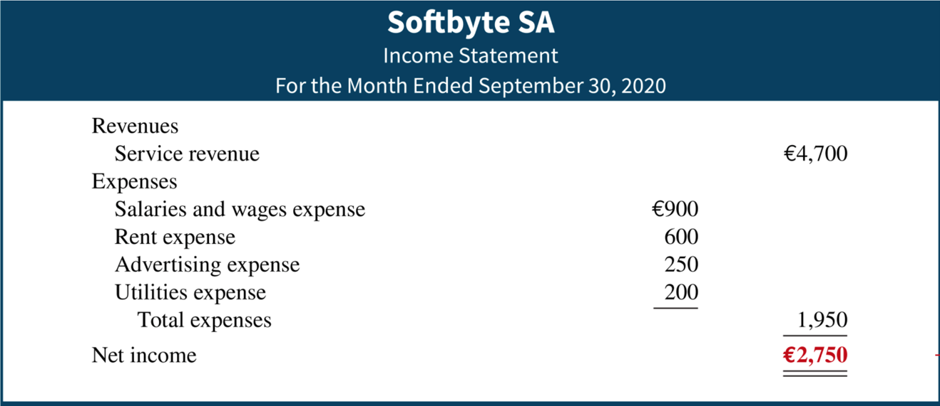

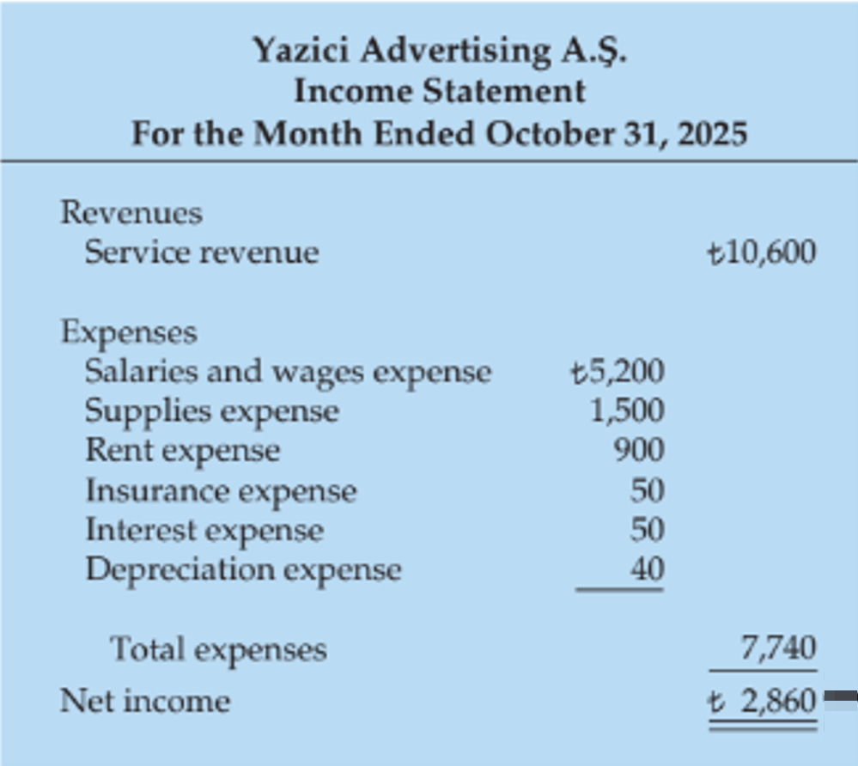 An illustration of an Income Statement is presented that contains a three-line heading consisting of the name of the company, P W Audio Supply; the type of statement, Income Statement; and the time period the statement covers, For the Year ended December 31, 2025. The statement consists of three columns with the first column displaying the account names and the other two presenting the respective amounts. The statement contains three sections. The Sales section is presented first with the calculation of gross profit, beginning with Sales. Sales revenue is next with Euro 480,000 presented in the third column. Less: Sales returns and allowances, and Sales discounts, are presented on the next two lines, with Euro 12,000 and 8,000 amounts, respectively, in the second column. The total of these two accounts is 20,000 and is presented in the last column followed by net Sales at 460,000 also listed in the last column. Cost of goods sold is next, and is presented as 316,000, followed by gross profit at 144,000. The operating expense section is next. Just below gross profit is the operating expenses section with the following account names and amounts listed in the first column: Salaries and wages expense, 64,000, Utilities expense, 17,000, Advertising expense, 16,000, Depreciation expense, 8,000, Freight-out, 7,000, and Insurance expense, 2,000. Total operating expenses is the sum of the above and is presented as 114,000 in the second numeric column. Income from operations, which is gross profit minus total operating expense, equals 30,000, presented in the second numeric column. The third section is Other income and expenses comprising of Interest revenue, 3,000, Gain on sale of equipment, 600, and Casualty loss from vandalism, negative 200 (shown in parentheses). The sum is presented in the second numeric column as 3,400. The Other expenses and losses section show Interest expense, 1,800 presented in the second numeric column. The next line presents Net income in the first column, with an amount of Euro 31,600 in the second numeric column.

8. **Retained earnings statement:** summarizes the changes in retained earnings for a specific **period of time**.

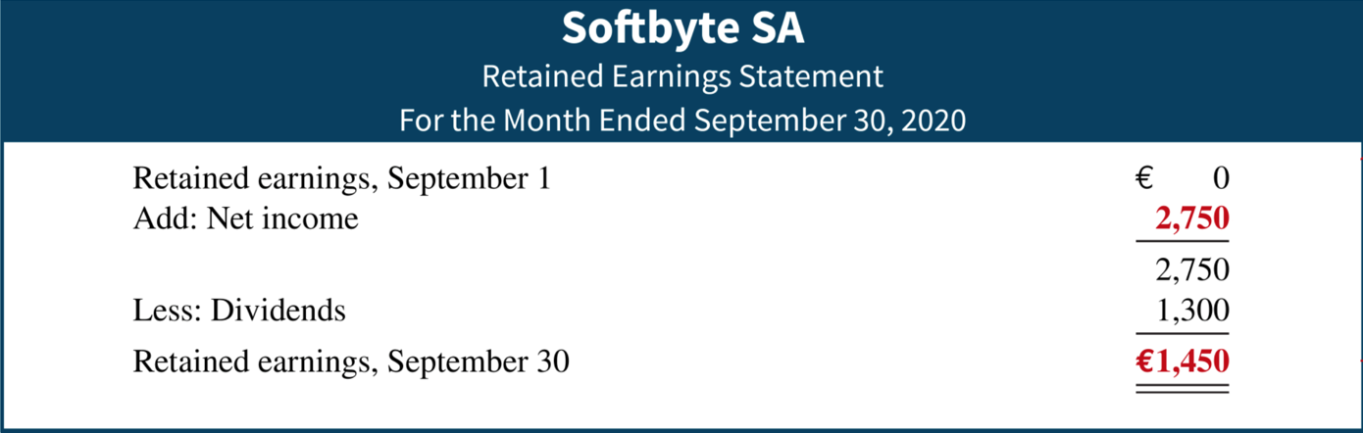

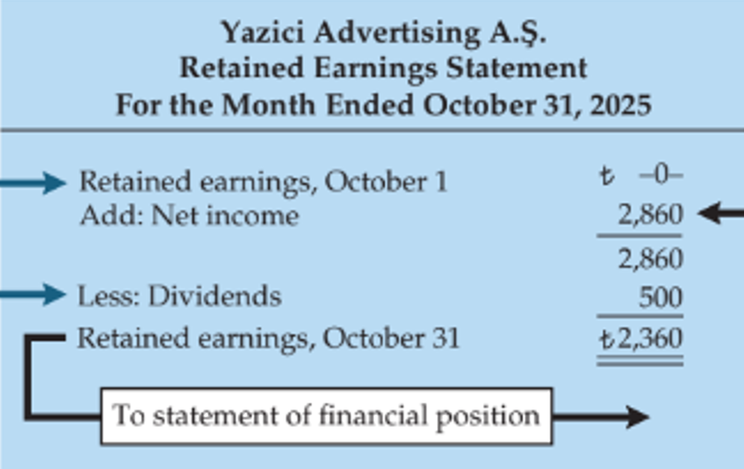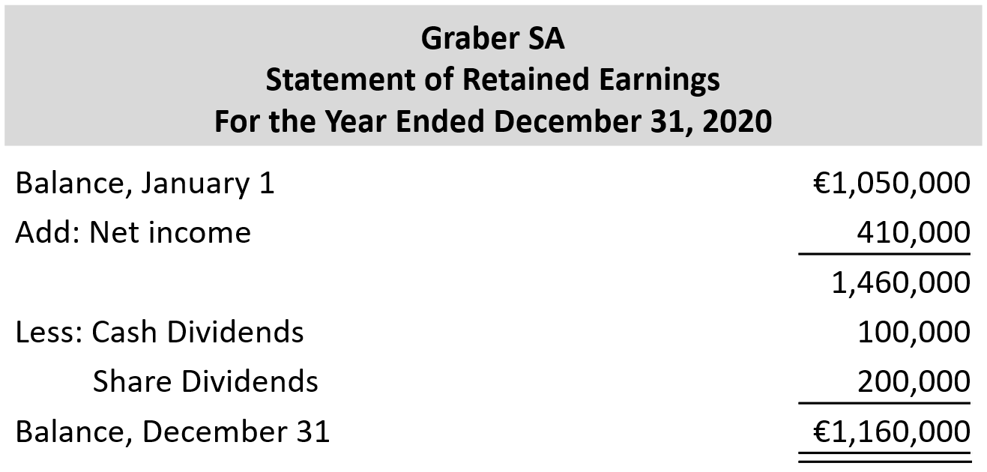

9. **Statement of financial position:** reports the assets, liabilities, and equity of a company at **a specific date**. (Sometimes referred to as a *balance sheet.*)

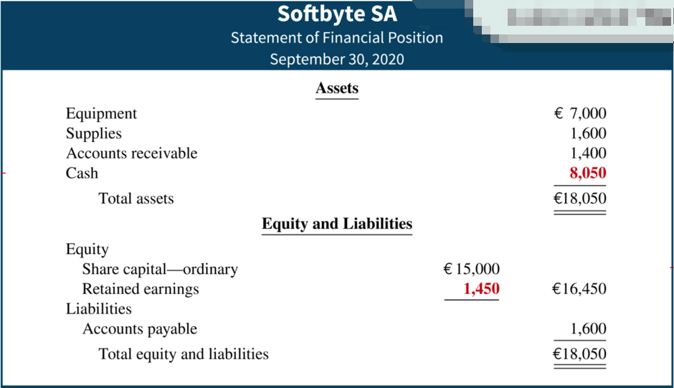

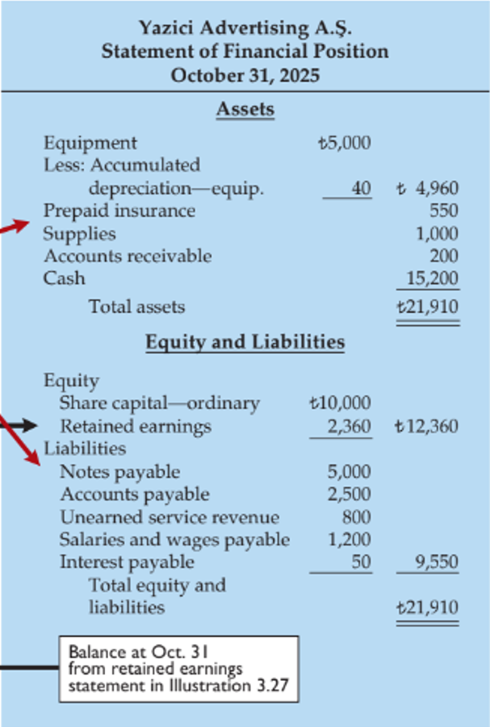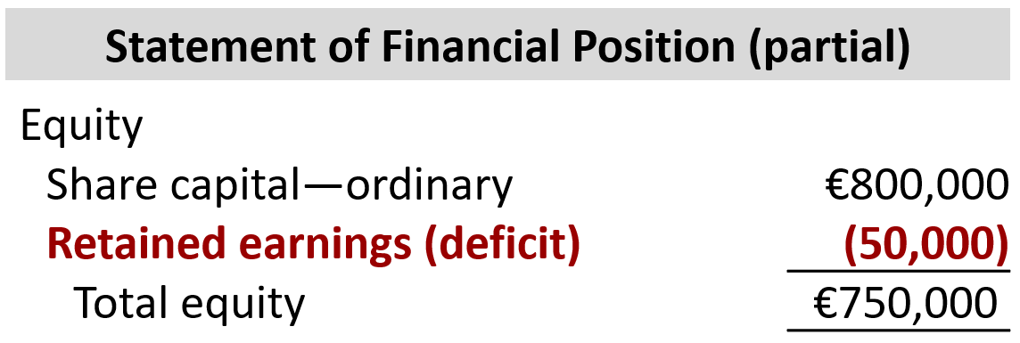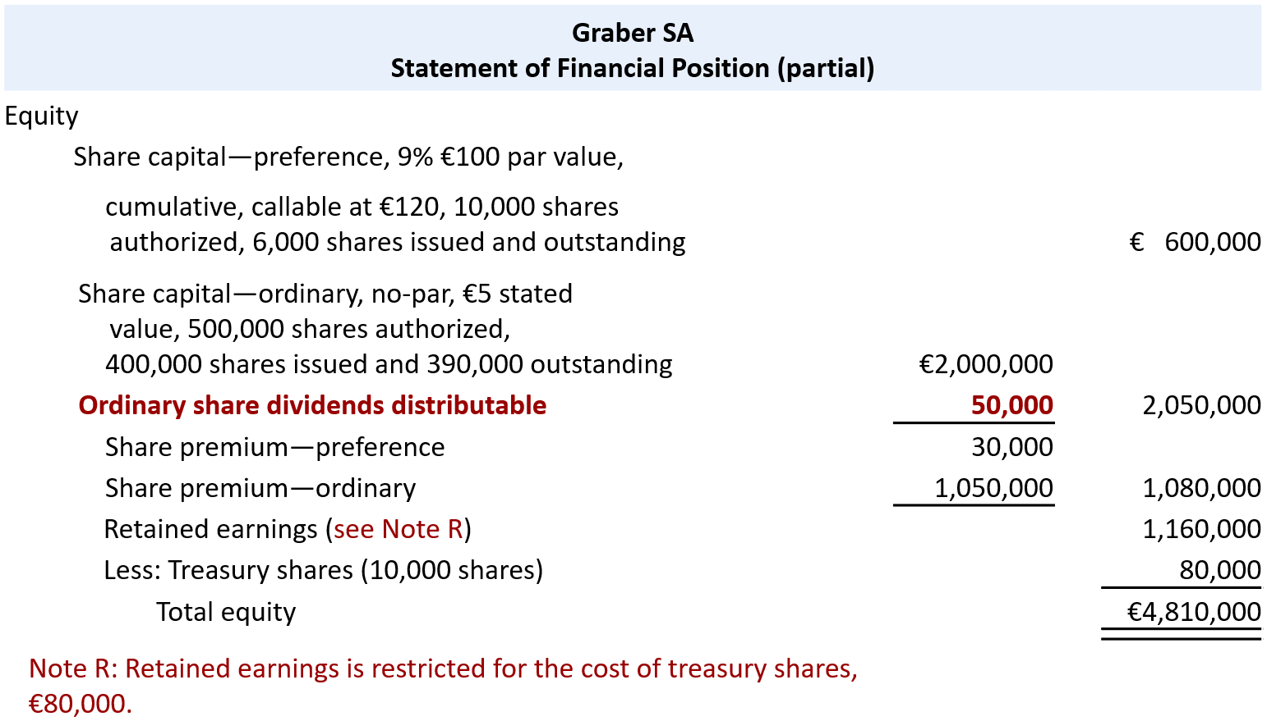

18. Classified Statement of Financial Position

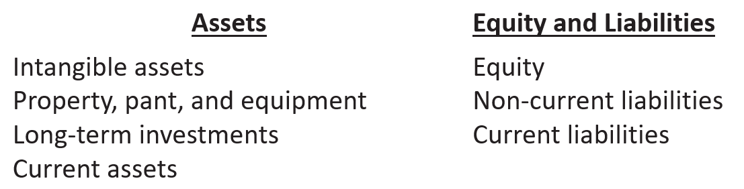

An illustration of a classified statement of financial position. The statement presents a four-line heading consisting of the name of the company, Cheng Limited; the type of statement, Statement of Financial Position; the date at which the statement is prepared, October 31, 2025; and the values in which the statement is prepared, (New Taiwan $ in thousands). This illustration presents the Assets section of the balance sheet, with the label, Assets, centered and shown in bold type, with 4 subsections listed below. There are 4 columns presented, the first presenting account names and the other three presenting the respective amounts and totals. The first asset subsection is labeled as Intangible assets in the first column. Immediately below slightly indented, Patents, is listed, with its respective amount of New Taiwan $3,100 presented in the last numeric column. The second asset subsection is labeled as: Property, plant, and equipment, in the first column. Immediately below with a slight indention appears a list of three accounts with their respective amounts: Land, listed in the second numeric column as New Taiwan $10,000; Equipment, listed as New Taiwan $24,000 in the first numeric column; and Less: Accumulated depreciation, listed as 5,000 in the first numeric column. The accumulated depreciation amount is subtracted from the 24,000 equipment cost, and the difference presented in the second numeric column as 19,000. The cost of the land of 10,000 is added to the net equipment amount of 19,000, and the total is presented in the second of the third numeric column as 29,000. The third asset subsection is labeled as Long-term investments. The following account names are indented slightly in this section, and the respective amounts appear in the second of two numeric columns: Stock investments, 5,200; and Investment in real estate, 2,000. The amounts are totaled as 7,200 which appears in the third numeric column adjacent to the 2,000 amount. The fourth subsection, Current assets, is presented in the first column. The following account names are listed in this section slightly indented with the respective amounts listed in the second of the three numeric columns: Prepaid insurance, 400; Supplies, 2,100; Inventory, 3,000; Notes receivable, 1,000; Accounts receivable, 7,000; Short-term investments, 2,000; and Cash, 6,600. The amounts are totaled as 22,100 which appears in the third numeric column adjacent to the 6,600 amount. Finally, the total of all four subsections is presented in the last numeric column as New Taiwan $61,400 with the label, Total assets, listed in the first column. 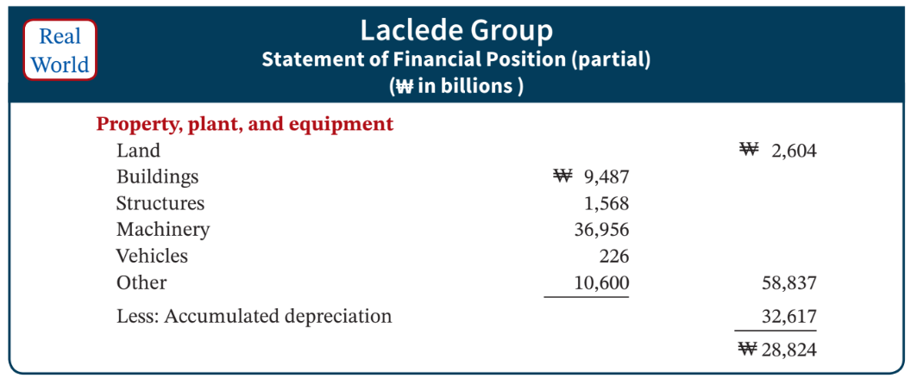 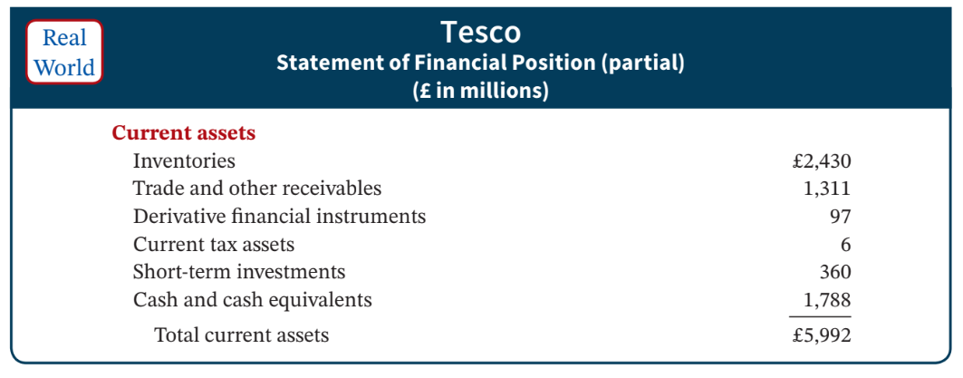



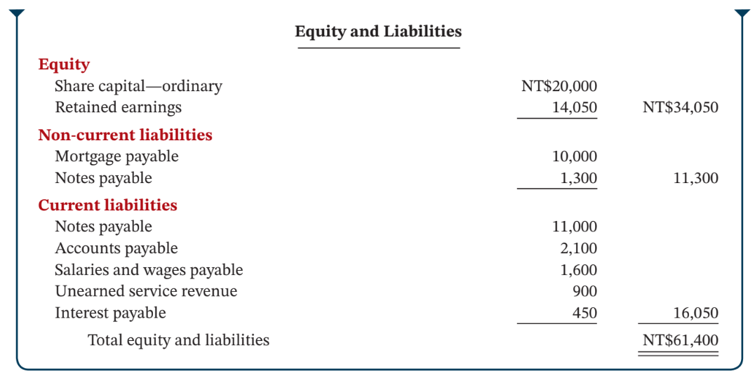



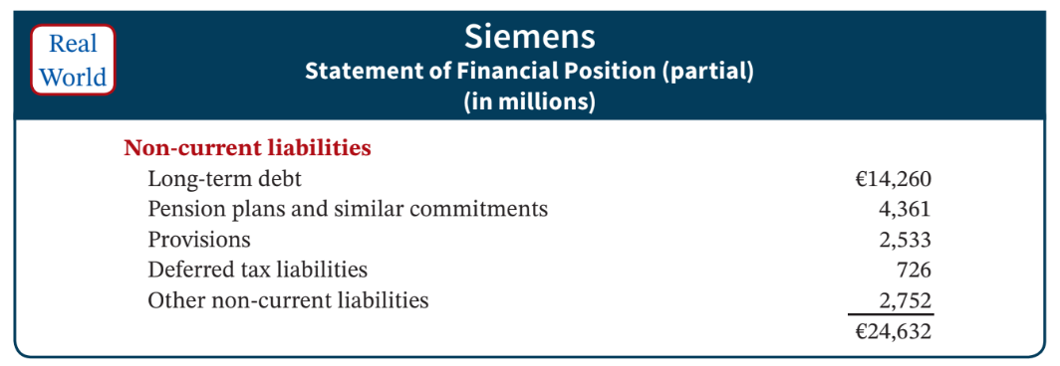 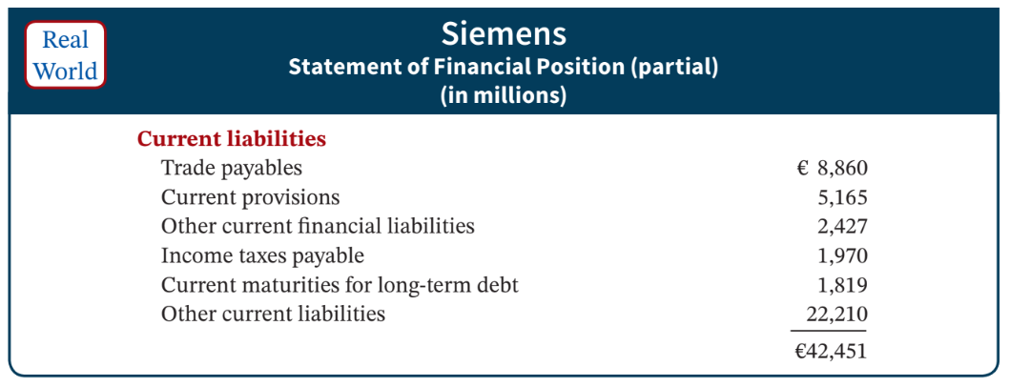

A statement presents a three-line heading consisting of the name of the company, Artex Enterprises; the type of statement, Statement of Financial Position (partial), and value in which the statement is prepared, (in billions). There are four columns, the first presenting the account labels, and the other three columns presenting the respective amount and totals. There are two sub-sections. The first subsection is, Property, plant, and equipment. The following account names are listed in this section slightly indented with the respective amounts listed in the three numeric columns: Gold mine, with the amount of Yen 530 listed in the first numeric column. Less: Accumulated depletion, with the amount, 210 are listed the first numeric column. The difference amount of 210 and Yen 530 is 320, which appears in the second numeric column adjacent to the amount, 210. Land with the amount, 600 listed in the second numeric column; Building with the amount, 7,600 listed in the first numeric column; Less: Accumulated depreciation-buildings with the amount 500 presented in the first numeric column. The difference amount of 7,600 and 500 is 7,100, which appears in the second numeric column adjacent to the amount, 500. Equipment with the amount, 3,870 and Less: Accumulated depreciation-equipment with the amount, 620 are listed the first numeric column. The difference amount of 3,870 and 620 is 3,250, which appears in the second numeric column adjacent to the amount, 620. The amounts are totaled as Yen 11,270, presented in the third numeric column, and the label appears in the first column as: Total property, plant, and equipment. The second subsection is Intangible assets. The following account names are listed in this section slightly indented with the respective amounts listed in the second numeric column: Patents, 440; Trademarks, 180; Goodwill, 900. The amounts are totaled as 1,520 and presented in the third numeric column adjacent to the amount 900. The amounts of Yen 11,270, and 1,520 in the third numeric column are totaled as Yen 12,790, with the label, Total assets appearing in the first column.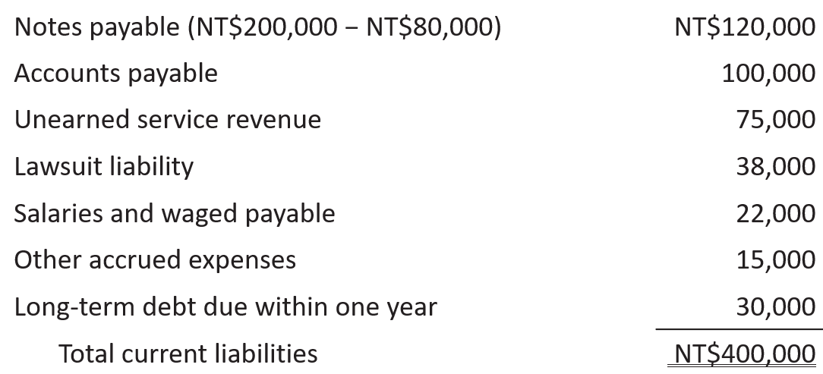

10. **Statement of cash flows:** summarizes information about the cash inflows (receipts) and outflows (payments) for a specific **period of time**.

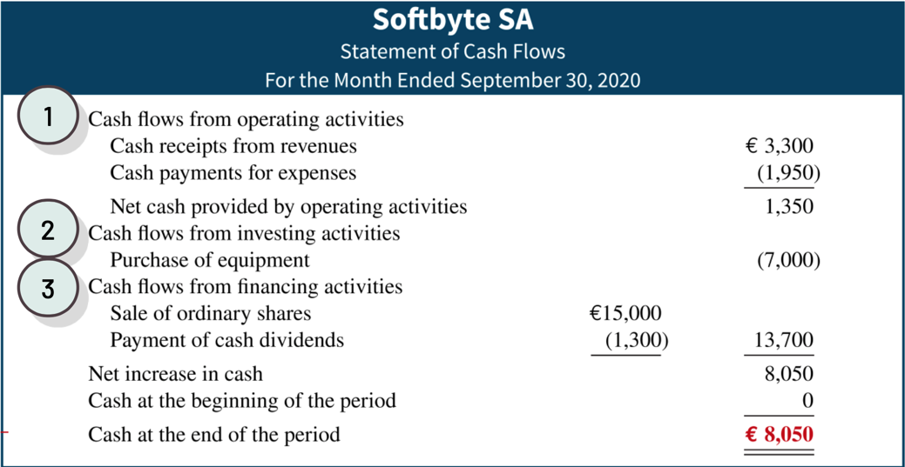An illustration of a statement of cash flows. The statement presents a three-line heading consisting of the name of the company, Company Name; the type of statement, Statement of Cash Flows; and the time period the statement covers, For the Period Covered. There are three columns in this statement, the first presenting labels and the other two presenting the respective numeric amounts. There are three sections in this statement: Cash flows from operating activities, Cash flows from investing activities, and Cash flows from financing activities. The cash flows from operating activities section contains one item for which the label, (List of individual items) appears slightly indented under the section label, with its amount of X X appearing in the first of the two numeric columns. The subtotal appears in the second numeric column as X X X with the label, Net cash provided (used) by operating activities appearing in the first column. The cash flows from investing activities section contains one item for which the label, (List of individual inflows and outflows) appears slightly indented under the section label, with its amount of X X appearing in the first of the two numeric columns. The subtotal appears in the second numeric column as X X X with the label, Net cash provided (used) by investing activities appearing in the first column. The cash flows from financing activities section contains one item for which the label, (List of individual inflows and outflows) appears slightly indented under the section label, with its amount of X X appearing in the first of the two numeric columns. The subtotal appears in the second numeric column as X X X with the label, Net cash provided (used) by financing activities appearing in the first column. The next line presents, Net increase (decrease) in cash. Its total of X X X appears in the second numeric column as the sum of amounts from each of the three sections. Immediately below net increase (decrease) in cash, Cash at beginning of period is presented as X X X. It is then added to the Cash at end of period in cash amount of X X X to arrive at the bottom line labeled Note x x, Non-cash investing and financing activities (List of individual non-cash transactions) with a total in the second numeric column of X X X.

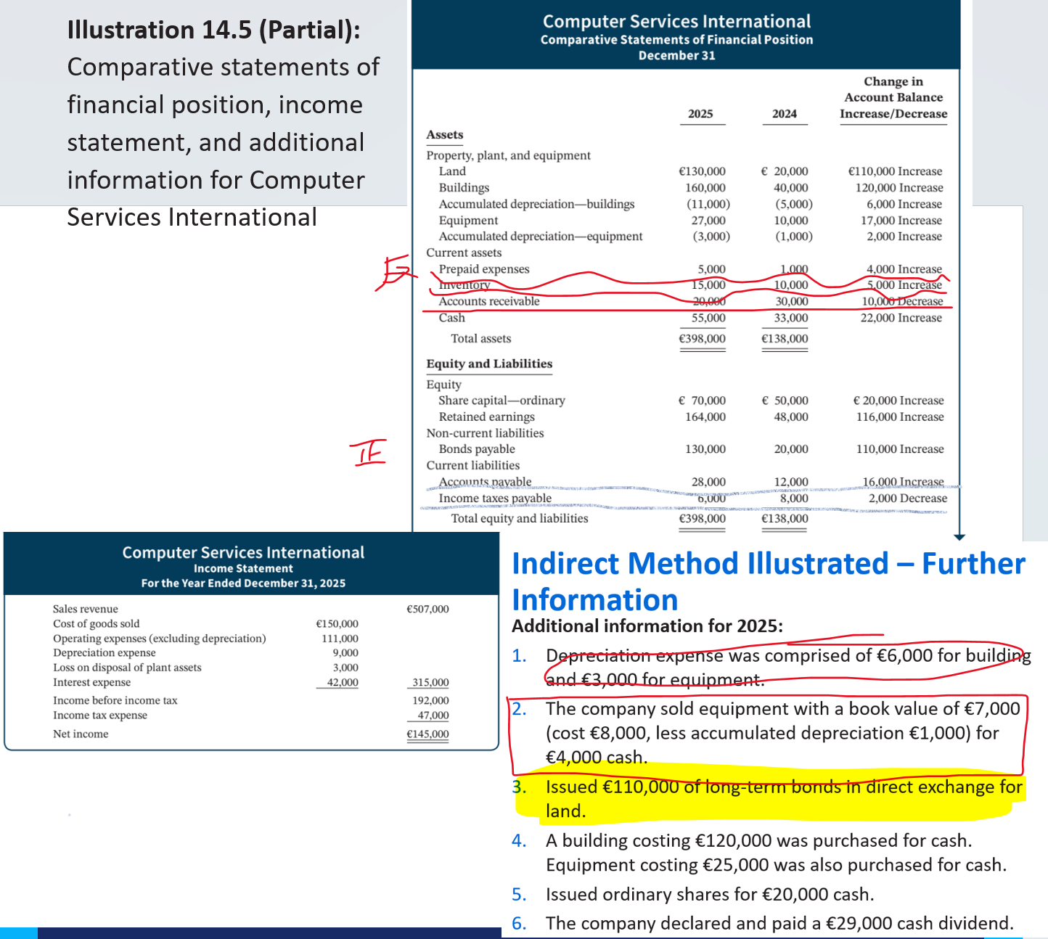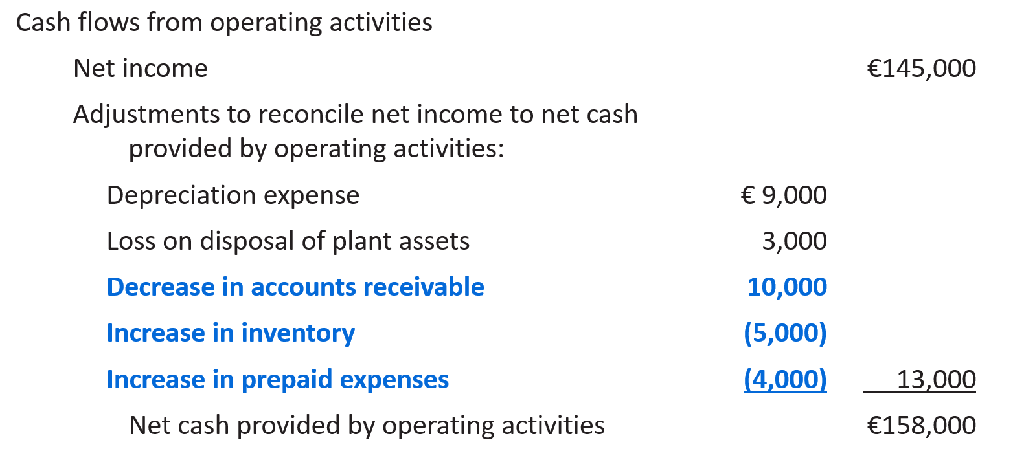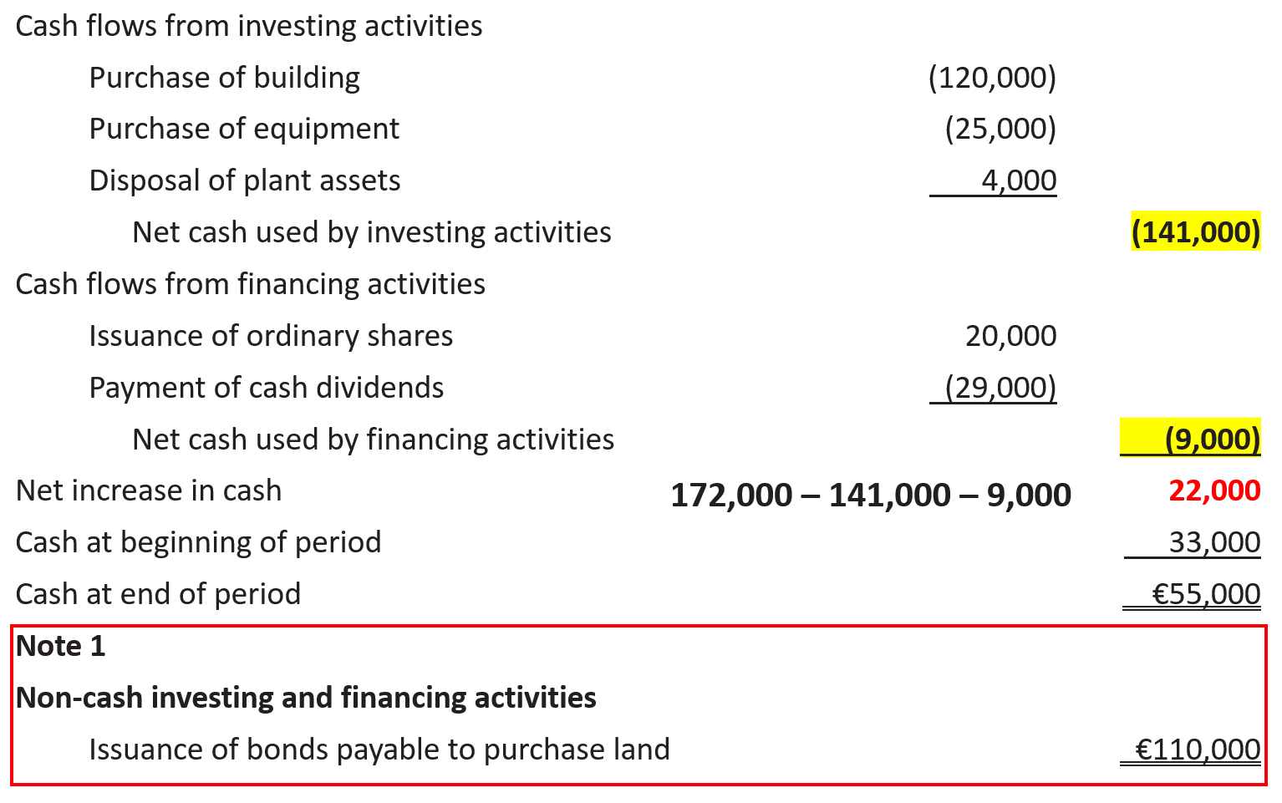

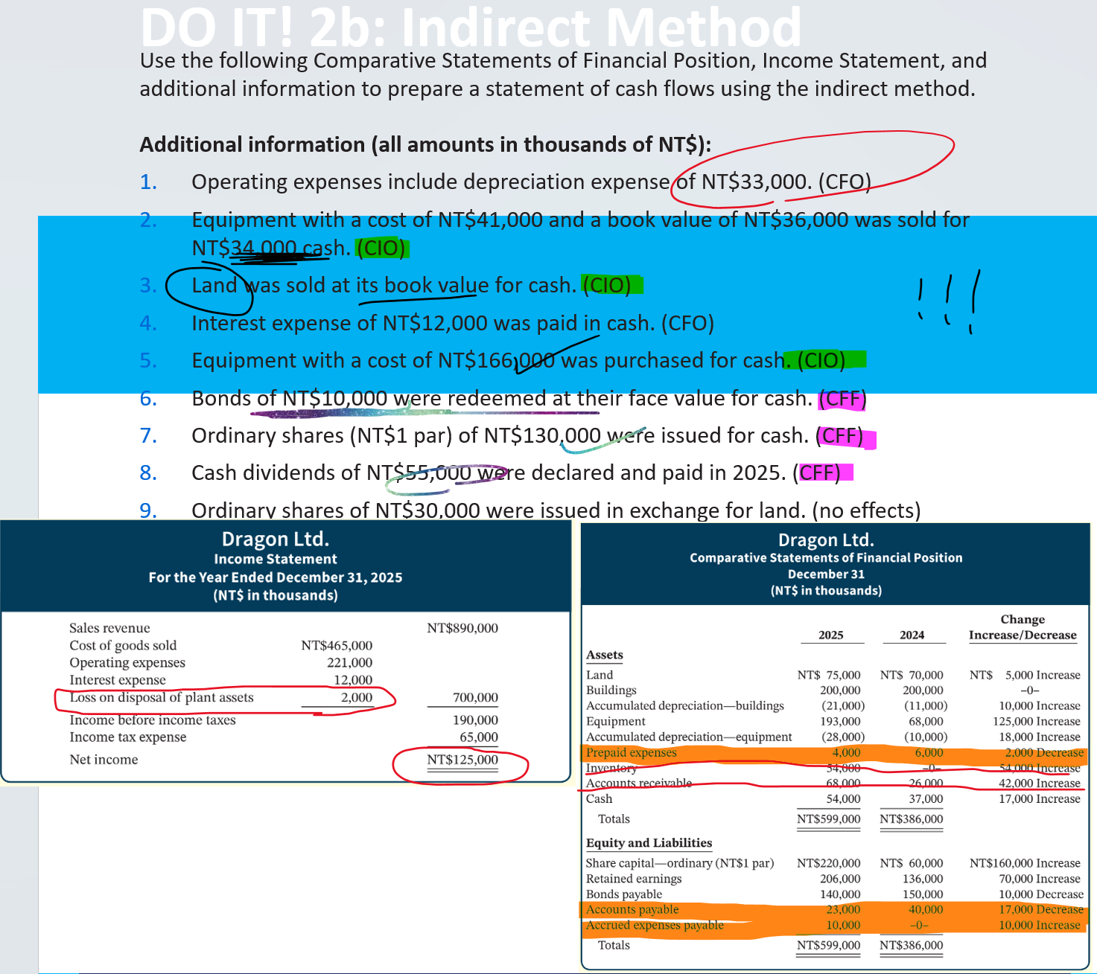

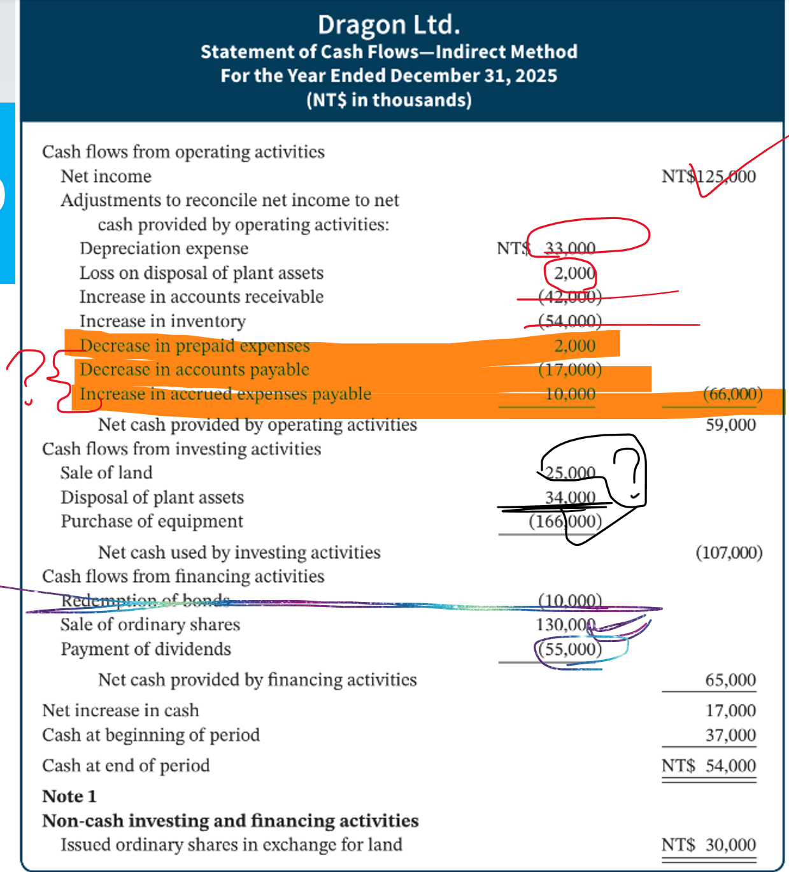

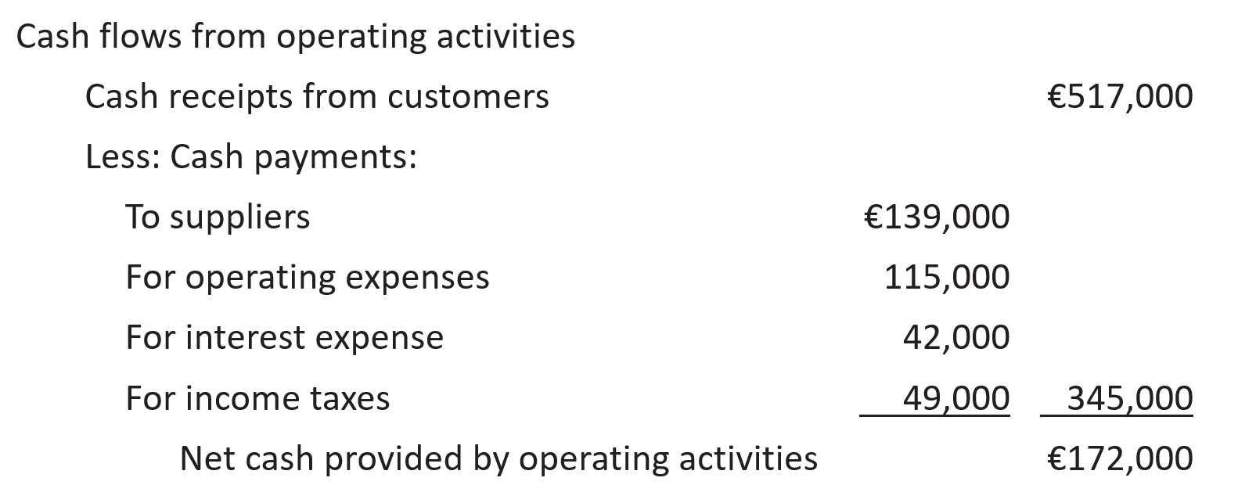

----- **Financial Statement Classification**

